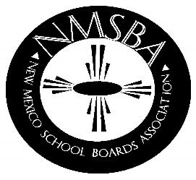
NEW MEXICO SCHOOL BOARDS ASSOCIATION
2019 Leadership Retreat
July 11-13, 2019
The Ruidoso Conference Center, Ruidoso, NM
Board Presidents, Officers & NMSBA Board of Directors

REGISTRATION FORM
Billing Address:
School District: __________
Submitted by: _____
Phone #: _____
Email: _____

ATTENDEES NAMES
(Please print)
1. Name:
Title

2. Name:
Title:

3. Name:
Title:

4. Name:
Title:

5. Name:
Title:

6. Name:
Title:

FEES:
Association Members: $150.00 per person. $175.00 per person after June 28, 2019. A purchase order is considered payment.
Purchase Order #:
(Attach copy of P.O.)

INCLUDED IN THE REGISTRATION:
Breakfast: Friday, July 12th & Saturday, July 13th
(Must have a reservation at the MCM Elegante)
Lunch: Friday, July 12th

Cancellations & Refund Policy
100% refund if registration is canceled in writing, by June 21, 2019.
50% refund if registration canceled in writing, by June 28, 2019.
NO SHOWS WILL BE BILLED IF NOT CANCELED BY DATES SHOWN ABOVE. Substitutions will be allowed up until the event.

HOTEL RATES at the MCM Elegante are $139.00 - $169.00 plus tax. Please make your own room reservations by calling (575) 258-5500. Also, please provide purchase order information at time of reservation and identify yourself as being with NMSBA. Reservations are not guaranteed in this hotel. Rooms are reserved on a first come – first reserved basis.

Please email registration form & P.O. to: NMSBA, Attention: Carolyn Mole, Finance Director
Email: cmole@nmsba.org

