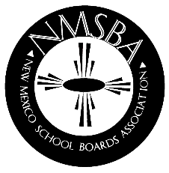
NEW MEXICO SCHOOL BOARDS ASSOCIATION
2019 Board Member Institute
February 21-23 - Eldorado Hotel - Santa Fe, NM

REGISTRATION FORM

School District:
Contact: Phone:_________________________________
Email:

ATTENDEES NAMES
(Please print)
- Name:
Title:

- Name:
Title:

- Name:
Title:

- Name:
Title:

- Name:
Title:

- Name:
Title:

FEES:
Association Members: $150.00 per person. $175.00 per person after January 26, 2018.
Purchase Order #: (attach copy of P.O.)

Non-Members: $450.00 per person. Payment must be made in advance.

Cancellations & Refund Policy
100% refund if registration is canceled in writing, by January 24, 2019.
50% refund if registration canceled in writing, by January 31, 2019.
NO SHOWS WILL BE BILLED IF NOT CANCELED BY DATES SHOWN ABOVE. Substitutions will be allowed until the event. NMSBA does not send out confirmations, you must call or email to confirm receipt of registration or cancellation. NMSBA’s policy dictates that we do not give refunds due to inclement weather.

HOTEL RATES at the Eldorado Hotel are $115.00 Single/Double, plus tax. Please make your own room reservations by calling 1-800-955-4455 and identify the NMSBA room block & p.o.# at time reservation is made. To ensure these rates, please make room reservations by February 1, 2019, and identify yourself as being with NMSBA.

Please Fax registration form & P.O. to
NMSBA FAX to: (505) 983-2450 or
email to: cmole@nmsba.org

