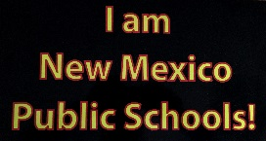
New Mexico School Boards Association

I am New Mexico Public Schools

Success Story Initiative

Submittal Form

Purpose of Initiative
I am New Mexico Public Schools is an advocacy initiative that encourages the submission of success stories about the many successes public schools are responsible for and all the positive things going on each day in public schools across New Mexico.

Topic of Success Story (Check all that apply)
Public School Graduate(s) Public School Board Member(s)
Public School Student(s) Public School Program(s)
Public School Staff Person(s) Other______________________

Title of Success Story

Success Story Narrative - Stories can be as short as 200 words or as long as 1,000 words. Please proof your story prior to submittal.

Image Guidelines - When possible, please attach a JPG (GIF, PNG or TIF) image to accompany your story.

Video Guidelines - Please provide a Web address if a video is available with your story.

Success Story Author

Name: Title:

Phone Number: Email Address:

Mailing Address:

I ____________________________________ hereby assume full responsibility for the accuracy of all information provided in this success story and further that I have secured the required parent permission for use of any student photos used in this story for posting on the NMSBA website

Signature ______________________________ Date____________

Please forward to NMSBA at 300 Galisteo St. Suite 204 Santa Fe, NM 87501 or email to Wendy Sawyer at wsawyer@nmsba.org

