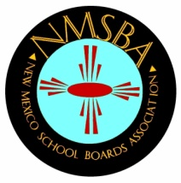
New Mexico School Boards Association
300 Galisteo St., Suite 204
Santa Fe, NM 87501
(505) 983-5041
FAX (505) 983-2450

Application for Associate Membership

Membership is effective July 1, 2017 – June 30, 2018

SCHOOL NAME:

ADDRESS:
State Zip

PHONE #:

EMAIL:

CONTACT PERSON:
Please enclose a business card

ASSOCIATE MEMBERSHIP:
Includes Charter Schools, Non-Public Schools and other Educational Agencies.

Benefits from Associate Membership benefits are limited to the following:

  - Non-voting associate membership status

  - Opportunities to earn credits towards state mandated training requirements at any of three NMSBA Conferences (Board Institute, School Law, Annual Convention)

  - Tracking and reporting of training credits to associate member and NM Public Education Department.

  - Member rates at conferences

PAYMENT INFORMATION:

Associate Membership is $1,350.00.

PLEASE ENCLOSE YOUR CHECK FOR THE TOTAL AMOUNT DUE MADE PAYABLE TO:

NEW MEXICO SCHOOL BOARDS ASSOCIATION
300 Galisteo St., Suite 204
Santa Fe, NM 87501

Special Note: NMSBA retains the right to cancel any membership for non-payment of invoices and will not report training credits to the NM Public Education Department for any conference which remains unpaid.

